WEST LONDON WASTE AUTHORITY
Report of the Circular Economy Manager | 24th Sept 2021
Circular Economy Update
SUMMARY
This report provides an update on the Authority’s Circular Economy activities.
RECOMMENDATION(S)

- The Authority is asked to note the information within this report.

- Waste Composition – WLWA performs a series of waste composition analysis every 15 months to capture the seasonal fluctuations in the makeup of residual waste. The analysis expanded this year to capture additional information from kerbside, communal and street waste to help inform the development of the Circular Economy Strategy.

The recent analysis carried out in June 2021 for communal and kerbside results are as follows:
- Food waste remains the greatest component in the residual waste and carbon contributor, despite a slight decrease in composition percentage to 32.06%
- Textiles remain the second-highest carbon content amongst the waste system
- Garden waste sees substantial growth in volume going from 2.38% to 7.95%
- Overall dry mixed recyclables within the residual stream dropped from 16.61% to 11.78%
- The drop in recyclables mirrors an increase in the non-recyclable combustible category. These materials are mainly packaging and account for up to 22.22% of the residual stream.
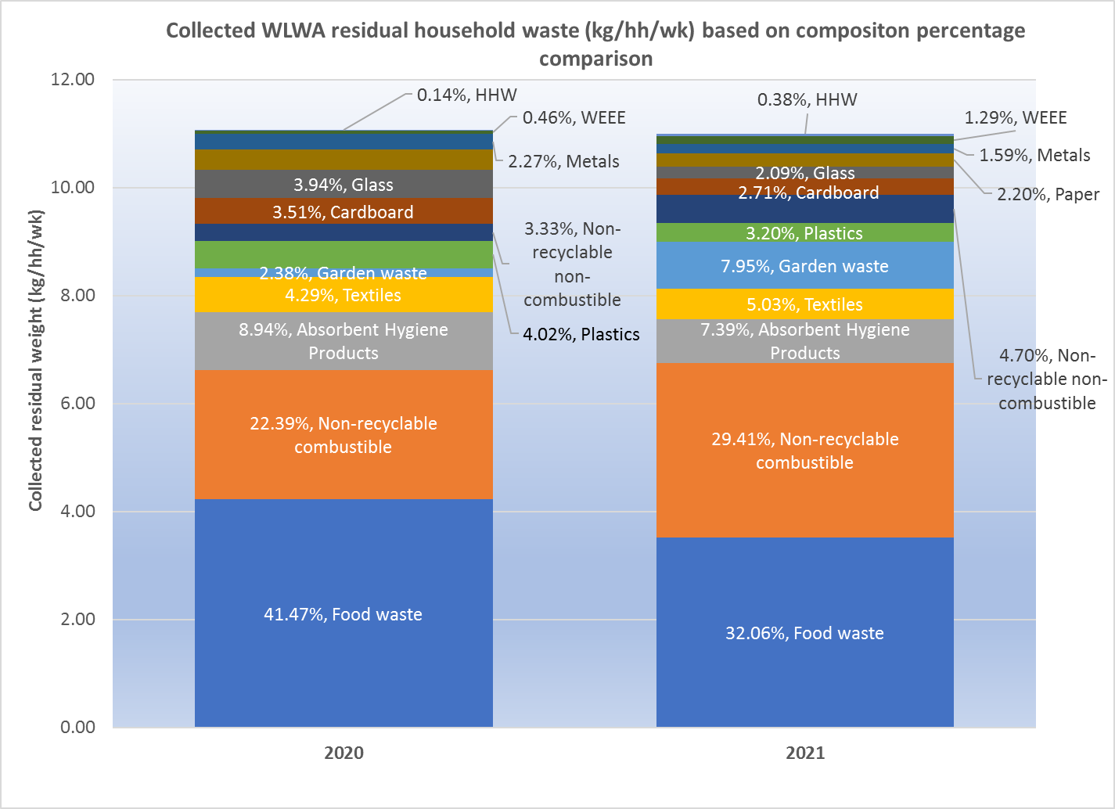

Officers are investigating and anticipating the impacts of the upcoming introduction of the Extended Producer Responsibility, Consistency and the Deposit Return Scheme. The chart in Appendix 1 shows that these affected materials will impact the overall residual system by approximately 22%.

The composition illustrates that more than 50% of the total waste falls within our key priority areas of food waste and materials covered by EPR and DRS.

Additional analysis will examine the causes of composition variance and understand the seasonality impacts versus systemic recycling collection capture rates. Using current data and further street waste analysis, officers will work closely with Borough colleagues to optimise collection systems and service provision.

- Increase reuse opportunities- West London Waste started collecting, baselining and redistributing reusable items collected through Household Reuse and Recycling Centres. Most items went to charities to support local projects like building outdoor classrooms and baby banks.

There are also immediate plans to repair and restore laptops and bicycles diverted from sites to support disadvantaged communities. The team finds that collecting reusable items is an uncomplicated task, but locating takers for all reusable items is the big challenge.

Officers are looking at opportunities to incorporate collected reusable materials to feed into the planned Circular Economy Hubs.

- Value-stream mapping - The team is currently mapping out all circular and partnership opportunities for current kerbside, communal, commercial, bulky and special collection services across west London and will be evaluating priorities shortly after.

- Circular Economy Hubs – The team produced a conceptual plan for a flagship CE hub and initiated discussions with SUEZ, borough partners and land acquisition teams to locate suitable sites and CE activities for each location that will serve its communities based on local demographics and social needs. A plan is currently being developed to align resources, partners and visions.

Appendix 2 shows a map of prospect sites. Blue points are sites suitable for large scale hubs, while green stars are sites suitable for implementing direct/internal circular activities.

Contact Officers | Peter Tilston, Projects Director  petertilston@westlondonwaste.gov.uk  Mildred Jeakins, Circular Economy Manager mildredjeakins@westlondonwaste.gov.uk  Motoko Doolan, Carbon Manager MotokoDoolan@westlondonwaste.gov.uk  Emma Beal, Managing Director  emmabeal@westlondonwaste.gov.uk | 01895 545510  01895 546623  07917 075876  01895 545515

Appendix 1
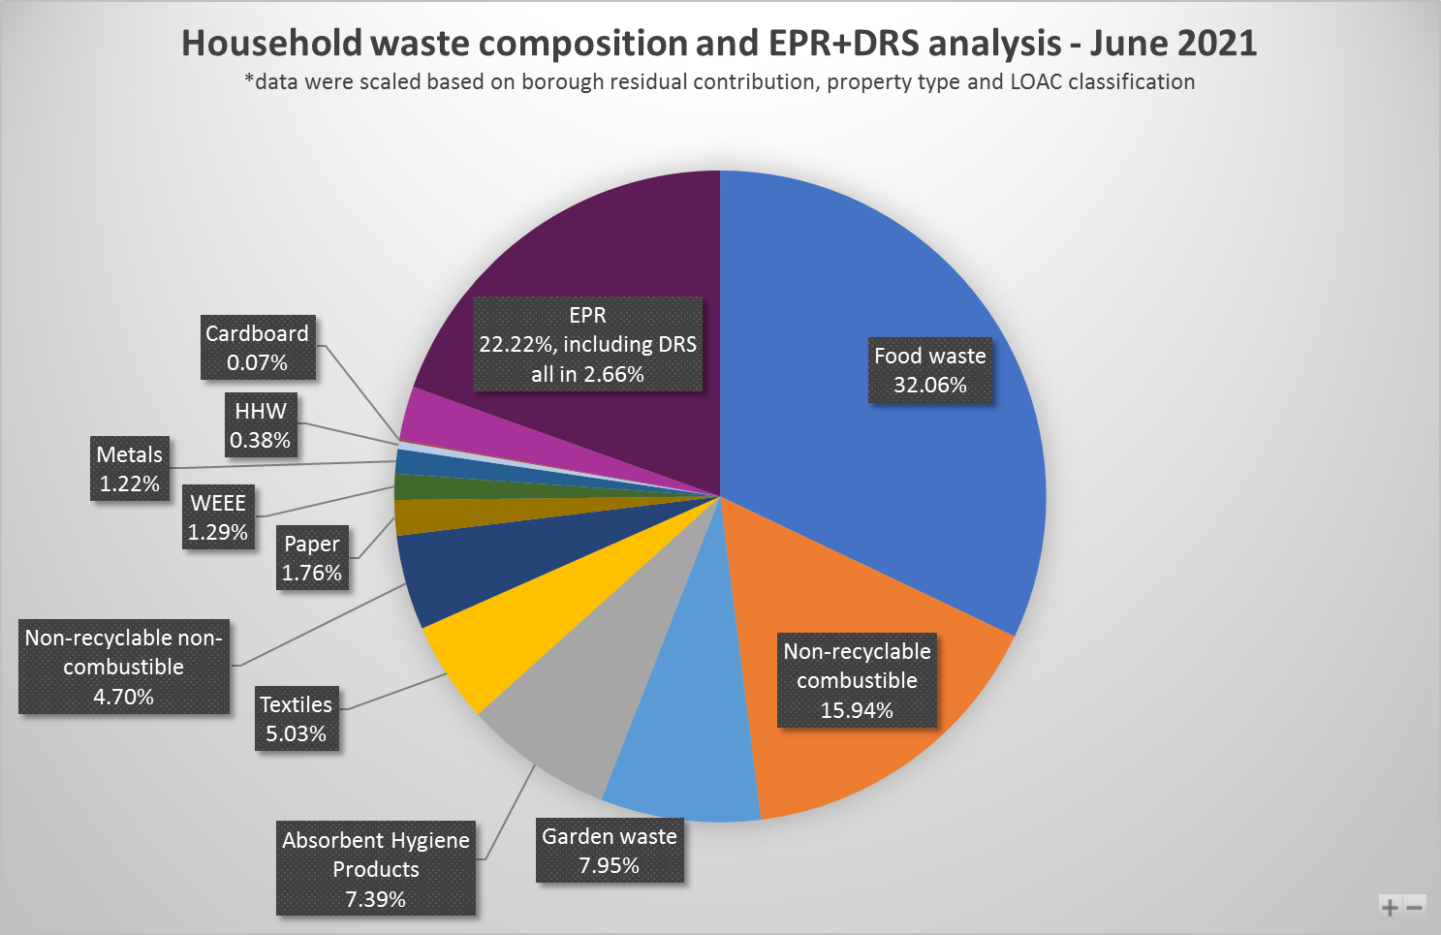

Appendix 2
Google maps 2021

